# Meeting Minutes 13-12-17 Games Jam

Start time: 11:00am

End time 17:00pm

Attended: Thomas Simmons, Callam Mutton, Quwaine Dantes

Not Attended: Blake Hewit due to joining another group

## Where the project is currently:

Our project progress in the past sprint week has been the following:

Thomas Simmons progress:

Callam Mutton progress:

Blake Hewit progress:

Quwaine Dantes progress:

## Games Jam Progress:

We all met in the labs at 11am to start with our games jam. Thomas suggested we all discuss possible themes we can think of and what we could use effectively in the time we have. We then using these themes came up with random scenarios for characters. This is shown on the attachment below.

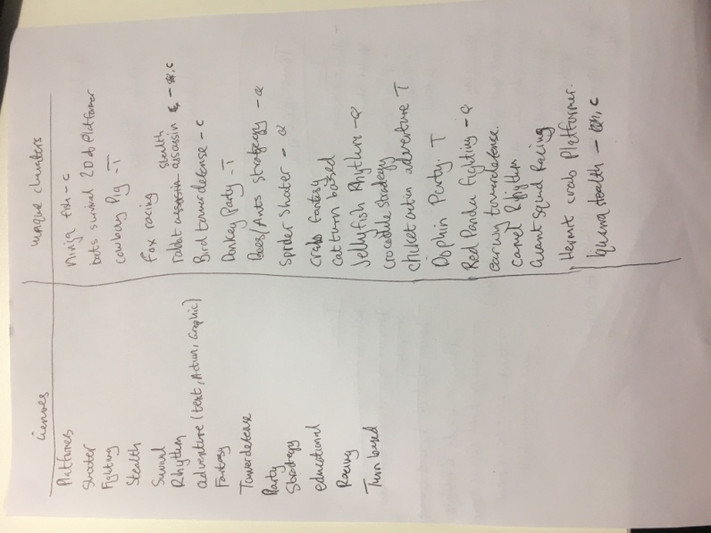

Then each group member chose four of their favourite character ideas and we put into a hat. Thomas then chose 3 ideas at random and they were Spider shooter, assassin rabbit and bird tower defence. We then moved on to create game ideas from these three character designs. This is shown below

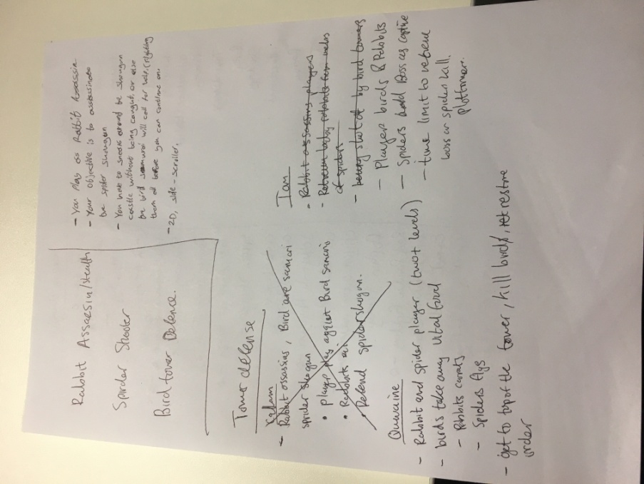

We then decided to go with Callam Mutton game idea which was the following:

The player plays as a ninja rabbit who has to sneak past the samurai bird guards in the spider shoguns castle without being spotted and killed. The spider shogun has a grip across the lands, taking 50% of young adults/ children and 50% of food in each province he rules to raise and feed his army. It’s the player’s job to kill this spider shogun and restore order across the lands.

### What we did with this game idea:

**Thomas Simmons** was tasked to create the samurai bird. He had to do the following:

* Research into samurai armour
* Research potential bird designs
* Create an bird design and he chose the bird to be an parrot
* Include an basic sketch of the bird with the armour included

**Quwaine Dantes** was tasked to create the spider shogun. He had to do the following:

* Research into shogun armour
* Research potential spider designs
* Create an spider design
* Include an basic sketch of the spider with the armour included

He was struggling on this so instead we as a group decided to get him to research and create and bsic layout of our level design.

**Callam Mutton** was tasked to create the ninja rabbit design. He had to do the following:

* Research into ninja uniform
* Research potential rabbit designs
* Create an rabbit design
* Include a basic sketch of the rabbit with the uniform.

Completed By: Thomas Simmons